
Benstein Outdoor Storage Solutions
Got Storage Problems? Call the BOSS!
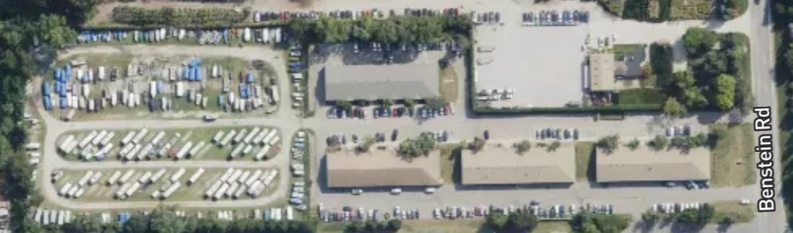
1046 Benstein Rd
Commerce Twp, MI 48382
Nick – 248 613 8008
Bob – 248 563 7280
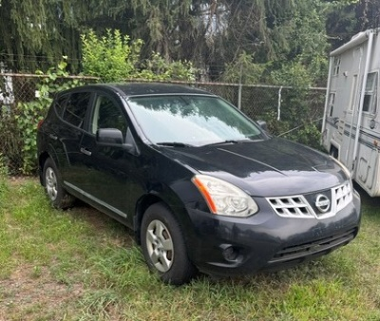
Vehicle Storage
10 Ft x 15 Ft Space
$50.00 per Month
Available spaces – 12
Call the BOSS to Reserve

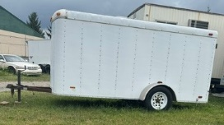
Small Trailer, Small Camper Storage,
Small Boat Storage
20 Ft x 12 Ft Space
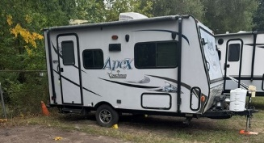
$ 65.00 per Month
Available Spaces – 20
Call the BOSS to reserve

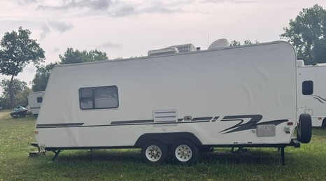
Medium Camper Storage,
Boat Storage
25 Ft x 12 Ft Space
$ 75.00 per Month
Available Spaces – 12
Call the BOSS to reserve

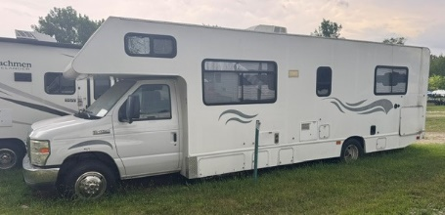
Large Camper Storage
30 Ft x 12 Ft Space
$ 85.00 per Month
Available Spaces – 8
Call the BOSS to reserve

Extra Large Camper Storage
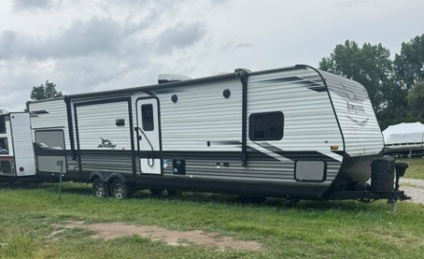
35 Ft x 12 Ft Space
$ 95.00 per Month
Available Spaces –8
Call the BOSS to reserve

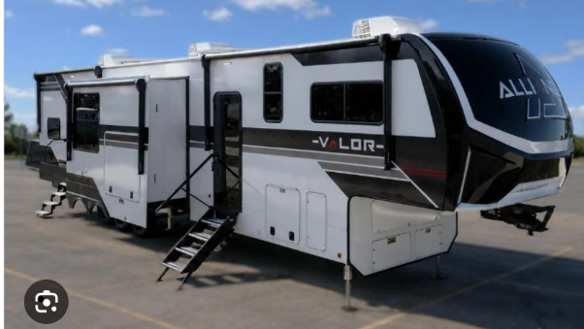
XX Large Camper Storage
45 Ft x 12 Ft Space
$ 125.00 per Month
Available Spaces – 2
Call the BOSS to reserve

